This line of latitude is called the Tropic of Antarctic Circl .
It is 66.5 degrees sout of the equator. . .
This line of latitude is called the Antarctic Circle .
It is 66.5 degrees sout south hhhh of the equator. .equator ..
This line of longitude is called the .
Name:
Mapping lines of latitude and longitude
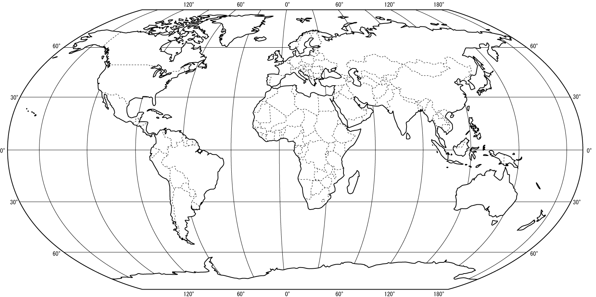

This line of latitude is called the equator

This line of latitude is called the Tropic of
quator . It is degrees of the .
This line of latitude is called the Antarctic Circle .
It is 66.5 degrees sout of the equator. ..

Extra Questions
- On the map draw and label the International Date Line.
- (In your book) Can you explain what the International Date Line is?

- (In your book) In as much detail as you can explain why the Prime Meridian is in Greenwich England.

- , E
This line of latitude is called the Tropic of CANCER .
It is 23 degrees NORTH of the equator. is the most northerly circle of latitude on Earth at which the Sun can be directly overhead
This line of latitude is called the Arctic Circle .
It is 66.5 degrees sout north of the equator. .equator ..
This line of longitude is called the .
Name:
Mapping lines of latitude and longitude


This line of latitude is called the equator

This line of latitude is called the Tropic of
CAPRICORN . It is 23 degrees south of the eqautor .
This line of latitude is called the Antarctic Circle .
It is 66.5 degrees sout of the equator. ..

it is thus the southernmost latitude where the Sun can be seen directly overhead.
Extra Questions
- On the map draw and label the International Date Line.
The International Date Line sits on the 180º line of longitude in the middle of the Pacific Ocean, and is the imaginary line that separates two consecutive calendar days. It is not a perfectly straight line and has been moved slightly over the years to accommodate needs (or requests) of varied countries in the Pacific Ocean.
- (In your book) Can you explain what the International Date Line is?
- (In your book) In as much detail as you can explain why the Prime Meridian is in Greenwich, England.
The line in Greenwich represents the historic Prime Meridian of the World - Longitude 0º. Every place on Earth was measured in terms of its distance east or west from this line. The line itself divided the eastern and western hemispheres of the Earth - just as the Equator divides the northern and southern hemispheres.

